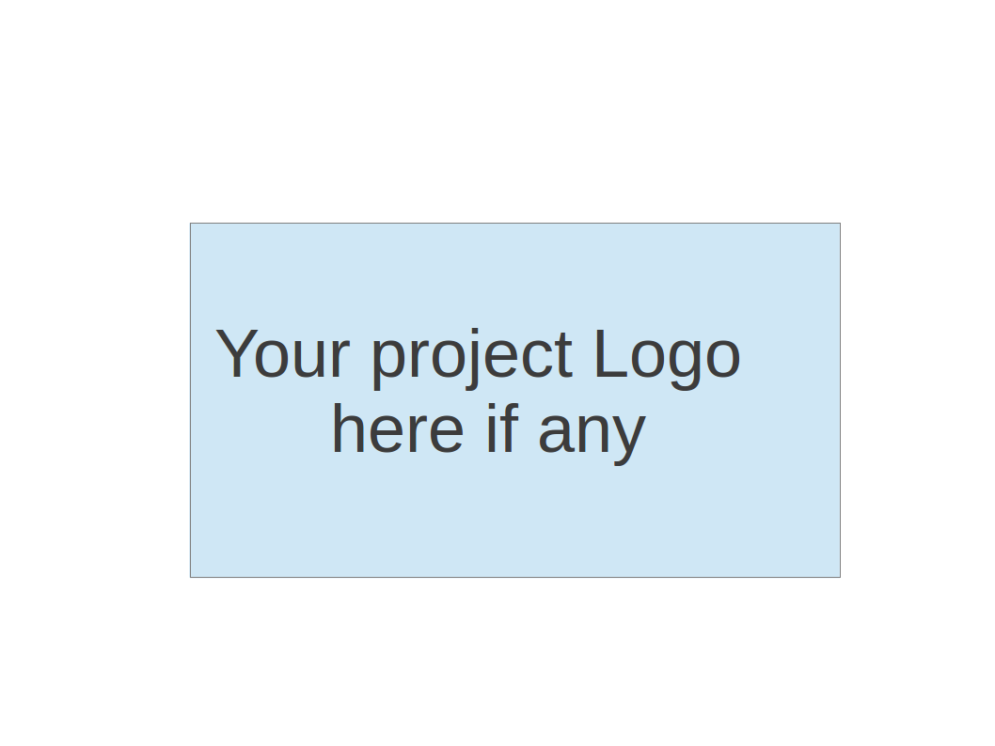
CS673 Software Engineering
Team X - Project Name
Software Test Document

Team Member | Role(s) | Signature | Date
Xuansheng Xia | Team Leader & Design and Implementation Leader | Xuansheng Xia | 11/07/2024
Xiaojuan Li | Requirement Leader | Xiaojuan Li | 11/07/2024
Hengyi Song | Security Leader | Hengyi Song | 11/07/2024
Ziliang Ren | QA Leader | Ziliang Ren | 11/07/2024
Mingyuan Xu | Configuration Leader | Mingyuan Xu | 11/07/2024

Revision history
Version | Author | Date | Change
Iteration 2 | Xuansheng Xia, Xiaojuan Li, Hengyi Song, Ziliang Ren, Mingyuan Xu | 11/07/2024

Testing Summary
Manuel Tests Reports
Automated Testing Reports
Testing Metrics
References
Glossary

Testing Summary
In this project, we conducted essential testing to ensure the robustness and functionality of our Django-based IMDb data analysis platform. The testing process included both manual and automated tests, focusing on integration testing, system testing, and acceptance testing.
Testing Overview
- Integration Testing: Integration tests were performed to verify that different parts of the application worked together seamlessly. This included testing the interaction between the Django backend and the MySQL database to ensure data retrieval and manipulation functioned as expected.
- System Testing: Comprehensive system tests were conducted on the platform's core functionalities. Key test cases included:
  - TC02_Home Page Load Test: Verified that the homepage loaded successfully with a 200 status code and correct HTML content type.
  - TC01_FunnelDataAPI: Tested the Funnel Data API, ensuring it returned the top 10 countries by movie production count, with each item in the response array having the expected structure (name as a string and value as a number).
- Acceptance Testing: Acceptance tests confirmed that the platform met end-user requirements and functioned correctly from the user's perspective. Tests like TC04_Update_Profile_View validated that user profile updates were correctly processed and displayed, while TC05_WordCloud Generation ensured the word cloud generation function produced the expected output from user text data.
Testing Techniques
- Manual Testing: Detailed manual test cases were performed on critical features. These tests were documented in the STD Manual Testing Report section, with each test outlining objectives, priority, dependencies, input data, expected output, and actual results. Screenshots were included for significant tests to provide visual confirmation of the outcomes.
- Automated Testing: Automated tests were incorporated into a CI/CD pipeline using GitHub Actions, allowing for automated builds and tests within a Docker environment. This setup facilitated consistent testing and deployment, ensuring stability across updates.
Testing Results
- Successful Tests: All manual and automated tests passed successfully. For example, TC02_Home Page Load Test and TC01_FunnelDataAPI validated that key application features were functioning as expected. Other tests, including data retrieval for the homepage and word cloud generation, also passed without issues.
- Defect Metrics: Throughout development, 30 defects were reported, of which 25 were resolved within the goal of 3 days, yielding a defect repair rate of 83.3%. With approximately 35,000 lines of code, the defect density was calculated at 0.00157 defects per LOC or 1.57 defects per 1,000 LOC, indicating a high level of code quality and robustness.
In summary, the testing process confirmed that the platform met its functional requirements and maintained stability across updates. The use of manual and automated testing techniques ensure thorough coverage, while defect metrics provide insights for continuous improvement.

Manual Testing Report
In this section, you will give a detailed description of each manual test case performed and the result. If this is a previous You shall list what are existing tests developed in the previous semester and what are new tests developed currently.

Here is a sample template that can be used for each test case. For system tests or acceptance tests, you may also include some screenshots.

- Test case ID, name
- New or old:
- Test items: (what do you test )
- Test priority (high/medium/low)
- Dependencies (to other test case/requirement if any):
- Preconditions: (if any)
- input data:
- Test steps:
- Postconditions:
- Expected output:
- Actual output:
- Pass or Fail:
- Bug id/link: (this should link to your github issue id)
- Additional notes:
(You can use an additional spreadsheet for this section as well)

Test Case ID: TC01_Funnel Data API Test – Xiao Juan Li
New or old: New
Test items: Verify that the funnel-data API endpoint returns the top 10 countries by movie production count with the expected JSON structure.
Test priority: High
Dependencies: The funnel-data API endpoint should be correctly configured and accessible.
Preconditions: The Django application server should be running, and the Docker container setup should be complete with any necessary migrations applied.
Input data: Request to the funnel-data API endpoint URL (/analysis/funnel-data/).
Test Steps:
- Start the Docker container using docker-compose up --build.
- Ensure that the Cypress test funnelDataAPI.spec.cy.js is included and set up in the /cypress/e2e/ directory.
- Run the test using Cypress, either automatically in Docker or manually in the Cypress test runner.
Postconditions: The system returns a JSON response for the funnel-data API endpoint URL.
Expected output:
- The response status code is 200.
- The content-type header of the response includes application/json.
- The response body is an array with 10 objects.
- Each object in the array contains the keys name and value, where:
  - name is a string representing a country.
  - value is a number representing the production count for that country.
Actual output:
- The response status code was 200, and the content-type was application/json.
- The response body contained an array of 10 objects, each with the expected structure.
Pass or Fail: Pass
Bug id/link: None (no issues were found during testing)
Additional notes:
This test case verifies that the funnel-data API endpoint is correctly configured to return the top 10 countries by movie production count in JSON format. The test case passed without issues, so no further debugging was required.

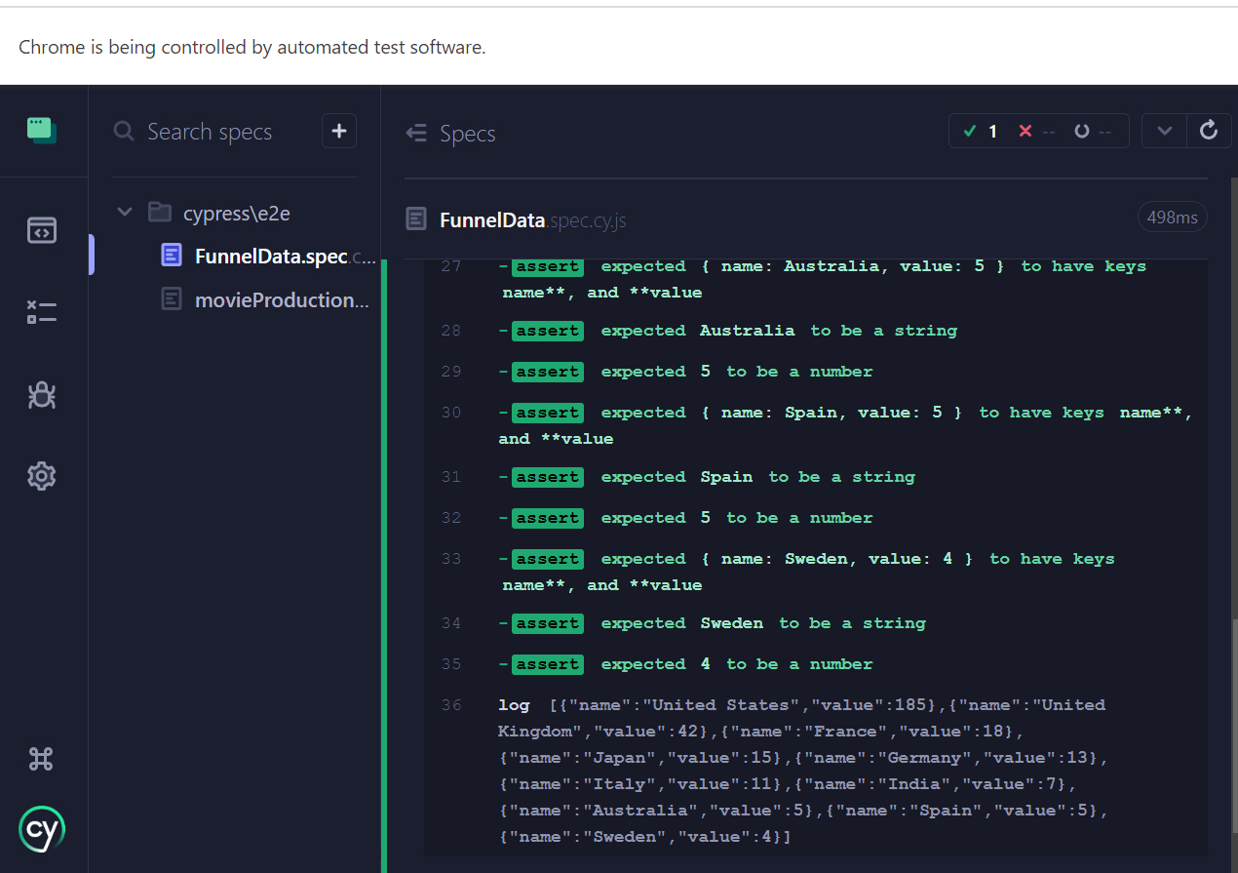

Test Case ID: TC02_Home Page Load Test - Xuansheng Xia
New or old: New
Test items: Verify that the home page loads successfully with a 200 status code and HTML content.
Test priority: High
Dependencies: None
Preconditions: The Django application server should be running, and the Docker container setup should be complete.
Input data: Request to the home page URL (/).
Test Steps:
- Start the Docker container using docker-compose up --build.
- Ensure that the Cypress test homePage.spec.cy.js is included and set up in the /cypress/e2e/ directory.
- Run the test using Cypress, either automatically in Docker or manually in the Cypress test runner.
Postconditions: The system returns a response for the home page URL.
Expected output:
- The response status code is 200.
- The content-type header of the response includes text/html.
Actual output:
- The response status code was 200, and the content-type was text/html as expected.
Pass or Fail: Pass
Bug id/link: None (no issues were found during testing)
Additional notes: This test case verifies the server's basic availability and the correct configuration of the home page URL. Since the test passed on the first attempt, no additional debugging was required.

Test Case ID: TC03_Homepage_DataRetrieval - Mingyuan Xu
Name: Homepage Data Retrieval Test
New or Old: New
Test Items: Verify that the application’s homepage can retrieve and display movie data accurately, including language, genre, rating distributions, and popular movies.
Test Priority: High
Dependencies: Dependent on the presence of movie data in the database.
Preconditions:
- The database should be populated with valid movie data including fields such as language, genre, rating, and title.
- The application must be running, and the test environment should be set up with the necessary packages and dependencies installed.
Input Data:
- HTTP GET request to the application’s root path (/).
Test Steps:
- Launch the application.
- Send a GET request to the root path using RequestFactory.
- Capture the response and its context.
- Verify the status code of the response.
- Validate the response context for:
  - list_json1 containing movie language distribution data.
  - x2 and y2 for genre distribution data.
  - x3 and y3 for rating distribution data.
  - list_json2 containing popular movie data.
  - x5, x4, and y4 for additional chart data (if applicable).
Postconditions: The response should return a status code of 200, with structured data in the response context.
Expected Output:
- Response status code should be 200.
- list_json1, x2, y2, x3, y3, list_json2, x5, x4, and y4 should all be valid lists with the required fields (value, name).
Actual Output:
- Response status code: 200.
- All context data validated as lists containing expected fields.
Pass or Fail: Pass
Bug ID/Link: N/A (No issues found during this test)
Additional Notes: This test verifies the basic functionality of the homepage data retrieval and ensures that all major data points are accurately captured and displayed. Future enhancements may involve testing for edge cases such as empty database scenarios or data format variations.

Test Case ID: TC04_Update_Profile_View - Hengyi Song
New or old: New
Test items:
Verify that the update_profile view correctly updates the user profile information, ensuring data is saved as expected.
Test priority: High
Dependencies: Relies on user authentication to access the update_profile view.
Preconditions: User must be logged in with appropriate permissions.
Input data:
username
email
first_name
last_name
Test steps:
1. Log in to the platform as a registered user.
2. Navigate to the profile update page (/profile/update/).
3. Fill in the profile form with the provided input data:
username
email
first_name
last_name
4. Submit the form to update the profile.
5. After submission, check that the user is redirected to their profile page.
6. Verify that the new profile information is displayed on the profile page.
Postconditions:
The user’s profile information should be updated in the database, and the changes should be reflected immediately on the profile page.
Expected output:
After form submission, the user should be redirected to their profile page, where the updated data (username, email, first_name, last_name) is correctly displayed.
Actual output:
The user was redirected to their profile page, and the updated profile information was displayed accurately.
Pass or Fail: Pass
Bug id/link: None

Test case ID, name: TC05 - WordCloud Generation - Ziliang Ren（success）
New or old: New
Test items: Testing the generate_wordcloud function in sentiment/views.py to ensure it retrieves text data, generates a word cloud, and returns it as a PNG image.
Test priority: High
Dependencies: Requires the UserText model to have entries in the database.
Preconditions:
- Django environment is set up correctly.
- The UserText model is available and accessible for queries.
- Required libraries for word cloud generation, such as nltk and wordcloud, are installed.
Input data:
- A UserText object with content: "This is a test text for word cloud."
Test steps:
- Use unittest.mock.patch to mock the UserText.objects.latest method to return a UserText instance with the specified test content.
- Create a simulated GET request to the generate_wordcloud endpoint.
- Call the generate_wordcloud function with the simulated request.
- Capture and analyze the HTTP response.
Postconditions:
- A word cloud image should be generated based on the provided text and returned as a PNG image.
Expected output:
- The response should be an instance of HttpResponse.
- The Content-Type of the response should be image/png.
- The response content (image data) should not be empty.
Actual output:
- To be filled after test execution (Expected: HttpResponse with image/png content type and non-empty response content).

Additional notes:
- This test does not interact with a real database but uses patch to simulate the database query.
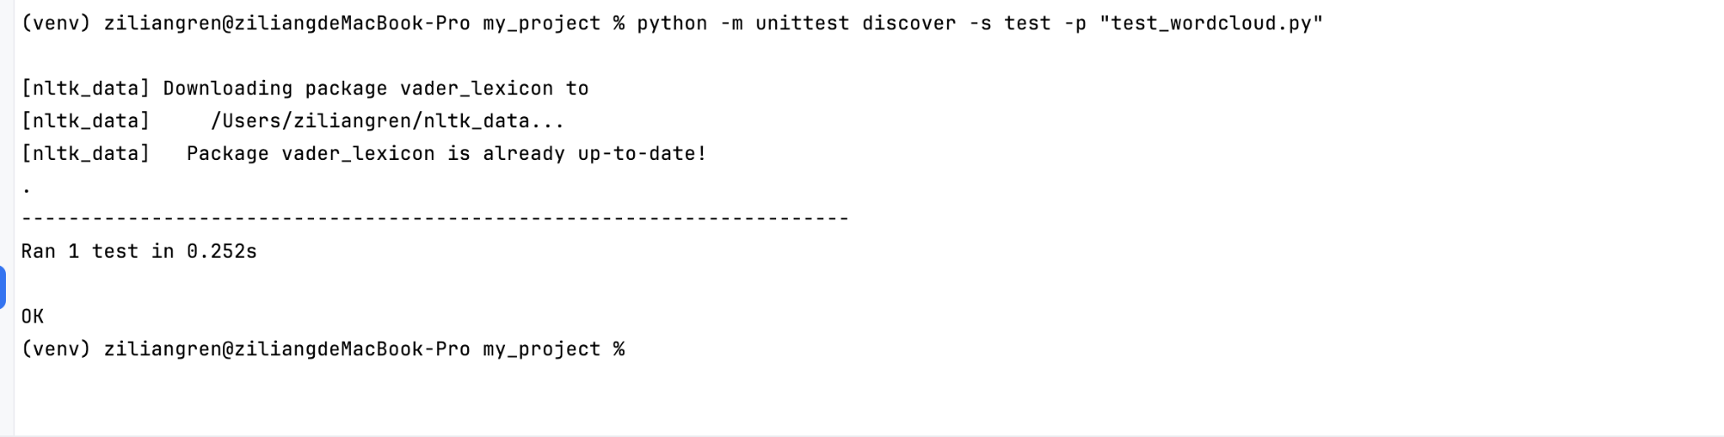
- Future enhancements could include testing with different lengths and types of text data to ensure generate_wordcloud handles various cases consistently.

Automated Testing Report - Xuansheng Xia
- Automated Testing Setup
Our project utilizes GitHub Actions for automated testing, configured through a YAML file named docker-push.yml. This file is located in the .github/workflows/ directory within the repository and defines the CI/CD workflow for our Django-based IMDb data analysis platform.
The GitHub Actions workflow performs the following:
- Build: Creates a Docker image of the Django project.
- Test: Runs automated tests within the Docker environment to ensure functionality.
- Push: If tests pass, the Docker image is pushed to Docker Hub for deployment.
- Location of Test Code
The automated tests for the Django application reside in the dataAnalysis/tests.py file. This file contains unit tests that validate the core functionality of the platform, such as ensuring that views render correctly and verifying data processing logic.
- Testing Frameworks Used
The project utilizes Django's built-in TestCase framework for writing and running tests. The framework allows for easy setup of test cases within Django and provides integration with GitHub Actions, enabling seamless CI/CD testing within our Docker environment.
- Security Considerations
To address security concerns, we have set environment variables using secrets.DOCKERHUB_USERNAME and secrets.DOCKERHUB_TOKEN within our workflow file. This security measure was proposed and implemented by our security leader to ensure sensitive information is not exposed.
- Workflow Steps
The automated testing workflow consists of the following key steps:
- Pull Source Code: Fetches the latest code from the repository.
- Set Up QEMU: Configures QEMU for multi-platform support.
- Set Up Docker Buildx: Enables Docker Buildx for cross-platform builds.
- Login to Docker Hub: Logs into Docker Hub using secure credentials.
- Build and Push Docker Image: Builds the Docker image and pushes it to Docker Hub under the latest tag.
- Generated Testing Report
Upon each execution, the workflow generates a report in the GitHub Actions “Actions” tab. This report logs the status of each step, including whether the image was successfully built and pushed to Docker Hub. Additionally, Docker Hub provides a record of the latest image, including its latest tag, compressed size, and the last pushed timestamp, which serves as confirmation of the most recent successful deployment.
- Screenshots
Below are screenshots that illustrate the automated testing process:
- GitHub Actions Workflow Overview: This screenshot shows the “Actions” tab with the Build-Dockerhub workflow and its successful execution steps, confirming the completion of each phase in the automation process.
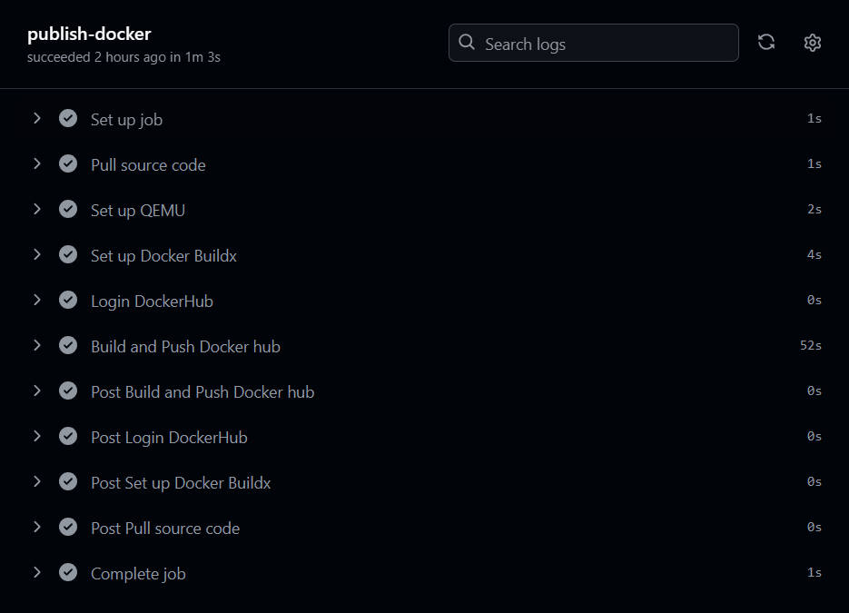
- Docker Hub Push Results: This screenshot shows the Docker Hub repository page with the latest tag and last pushed timestamp, demonstrating the automated push result and verifying deployment consistency.
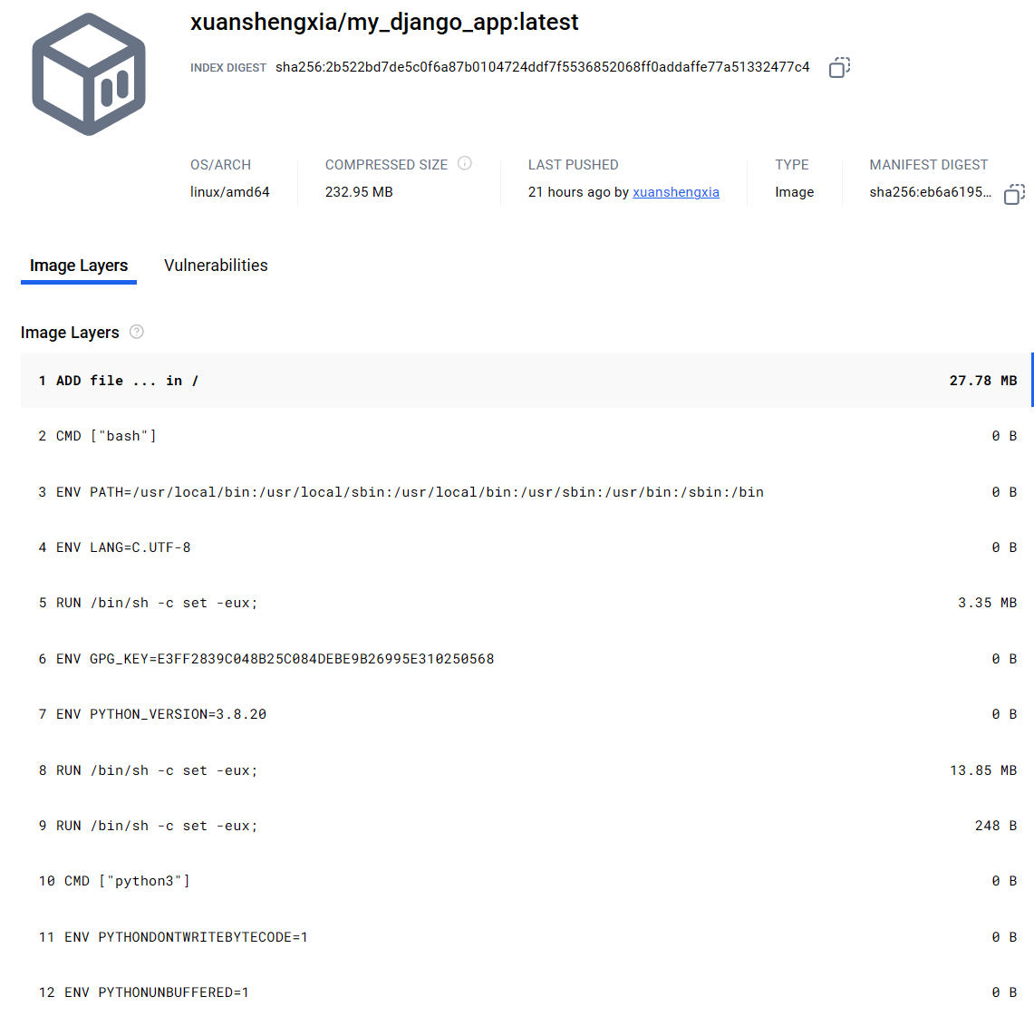

Testing Metrics - Ziliang Ren
In this section, you shall report any metrics used for the evaluation, e.g. # of test cases, test coverage, defects rate, etc.

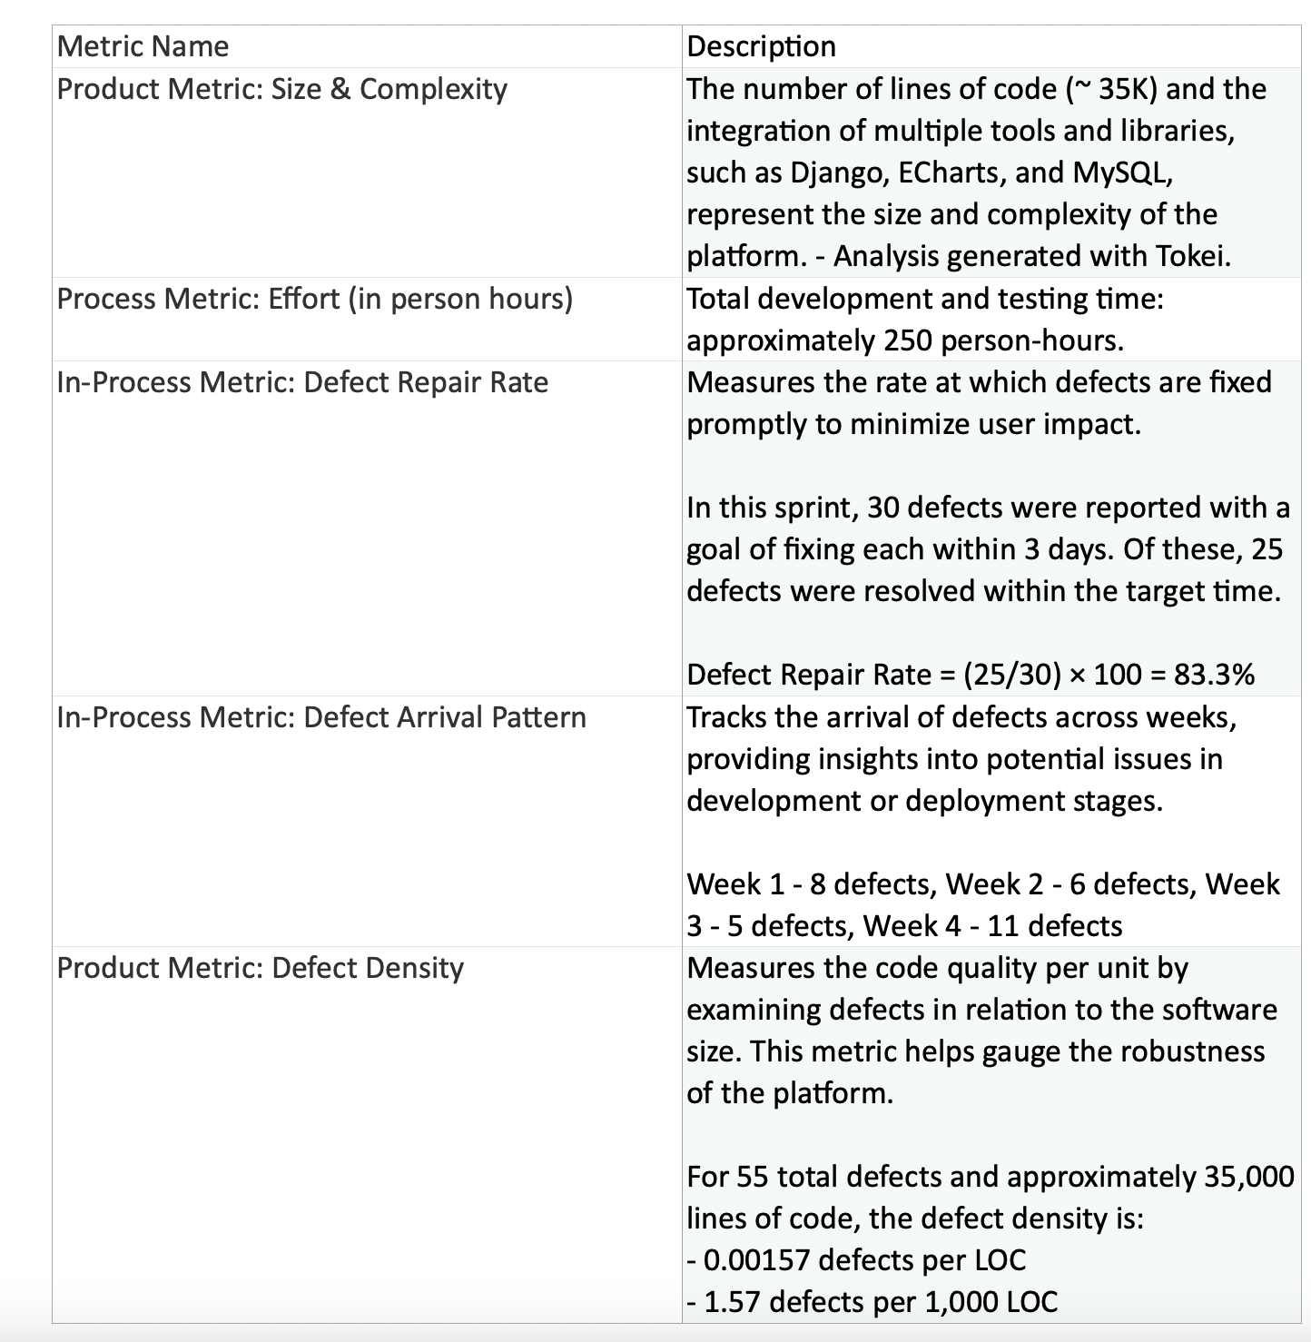

References

Glossary

